**Platelet satellitism around neutrophils in a four-year-old girl with urinary tract infection: A case report**

**Authors**:

Hashem Zamani[1], Mohammad Ghorbani[2], Arian Taghdiri[3]

**Corresponding author:**

Dr. Jalil Moshari[4]

**Abstract:**

**Introduction:** Platelet satellitism is a rare in vitro phenomenon , which is considered as one of the causes of pseudo thrombocytopenia. This phenomenon is almost always observed in peripheral blood smears prepared from blood samples containing EDTA anticoagulant and at ambient temperature although it is not visible at lower temperatures and in blood samples treated with other anticoagulants. If the peripheral blood smear is not performed, this can cause misdiagnosis of thrombocytopenia. In this case, the platelet count of a 4-year-old child was checked in the laboratory for platelet satellitism.

**Methods:** The patient's blood samples were collected with both EDTA and sodium citrate anticoagulants separately , and the platelet was counted with cell counter. At the same time as the platelet count was done by the device, the peripheral blood smears were also analyzed. No bleeding symptoms were observed in the patient.

**Findings:** Platelet count in the sample with EDTA anticoagulant was 85×109/L, and in the peripheral blood smear prepared from this sample, the platelet satellitism was observed only around neutrophils. However, there was no platelet satellitism in the sample prepared with sodium citrate anticoagulant and the patient's platelet count increased to 242×109/L.

**Conclusion:** Platelet satellitism is a rare phenomenon that can lead to laboratory error by inducing pseudo thrombocytopenia. This condition should be considered in thrombocytopenia cases without clinical symptoms because it may have negative effects on the patient's care process by performing inappropriate therapeutic interventions.

**Introduction:**

Platelet satellitism (PS) is a rare and interesting phenomenon in the laboratory environment, which refers to the accumulation of platelets in the form of rosettes or multiple bundles around white blood cells.(1, 2) This platelet aggregation is mainly seen around neutrophils and sometimes also around other blood cells such as monocytes, lymphocytes, eosinophils or basophils.(3) This phenomenon is almost always observed in peripheral blood smears prepared from blood samples containing EDTA anticoagulant and at room temperature, while it is not visible at lower temperatures and in blood samples prepared with other anticoagulants such as heparin or sodium citrate.(4, 5)

To date, a precise and specific mechanism for the platelet satellitism has not been described. Nevertheless, it is believed that immunological and non-immunological mechanisms play a role in the occurrence of this phenomenon.(1, 6) Several theories and potential mechanisms have been proposed in the literature. One such hypothesis refers to an immunological mechanism stating that IgG autoantibodies present in a patient's serum form an immune complex with hidden antigens on the platelet membrane glycoprotein IIb/IIIa complex. These antigens do not appear until the calcium ion is removed from the environment by EDTA anticoagulation and the membrane is spatially deformed. These immune complexes are absorbed by the surface of neutrophils or other leukocytes through binding to the Fcγ receptor and eventually lead to the accumulation of platelets in a rosette-like form around the leukocytes.(1, 4, 5, 7) On the other hand, the adhesion of platelets to neutrophils mediated by thrombospondin or other platelet alpha granule proteins such as P-selectin has been proposed as a non-immunological mechanism.(1, 2)

Platelet satellitism is usually seen in healthy people, but cases of it have also been reported in various pathological conditions, including infectious diseases. However, it has not yet been specifically linked to any particular drug or disease.(5, 8)

This phenomenon can lead to a false decrease in platelet counts by autoanalyzer, resulting in a misdiagnosis of thrombocytopenia. If this condition is not diagnosed correctly, unnecessary diagnostic and treatment measures may be taken and have negative effects on the patient's care process.(2) In this case report, we describe platelet satellitism in a patient with a urinary tract infection, and with a review of literature, we discuss possible mechanisms to better understand its nature.

**Case report:**

The patient is a 4-year-old girl with no specific clinical history who went to the doctor due to high fever and urinary tract infection. Physical examinations revealed the absence of splenomegaly and lymphadenopathy. Also, the child did not have any clinical symptoms caused by thrombocytopenia such as petechiae, purpura, easy bruising, epistaxis and bleeding gums. Complete blood cell (CBC) counts in EDTA anticoagulation performed by hematology autoanalyzer showed red blood cell (RBC) (4.47×1012/L), white blood cell (WBC) (13.3×109/L) and platelet (Plt) (85×109/L) counts. )Table1) Due to the observation of thrombocytopenia in CBC, peripheral blood smear (PBS) was prepared from a blood sample containing EDTA anticoagulant and Wright _ Giemsa staining was performed. This PBS examination showed the platelet satellitism only around neutrophils and platelet aggregation was not observed around other types of leukocytes (Figure 1)

|  |  |
| --- | --- |
| C.B.C | Result |
| WBC | 13.3×109/L |
| RBC | 4.47×1012/L |
| Hemoglobin | 11.8 g/dL |
| Hematocrit | 35.2 % |
| MCV | 78.7 fL |
| MCH | 26.4 pg |
| MCHC | 33.5 g/dL |
| Platelet | 85×109/L |
| MPV | 7.2 fL |

Table 1: Laboratory values of hematological parameters of the patient's blood sample with EDTA anticoagulant

CBC: Complete blood count; WBC: white blood cells; RBC: red blood cells; MCV: mean corpuscular volume; MCH: mean corpuscular hemoglobin; MCHC: mean corpuscular hemoglobin concentration; MPV: mean platelet volume

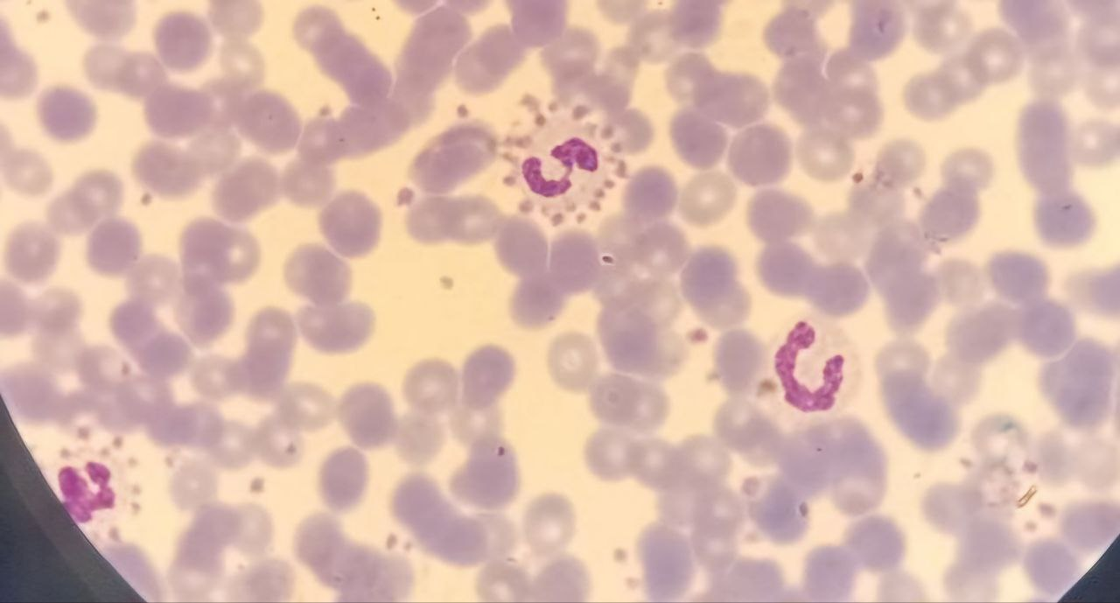

Figure 1: platelet satellitism around 3 neutrophils

After that, another sample was obtained with sodium citrate anticoagulant, and in the PBS examination prepared from this blood sample, no platelet accumulation was observed around the leukocytes. Also, the patient's platelet count increased to 242×10^9/L after correction due to dilution in sodium citrate. It should be noted that all analyzes were performed with Mindray BC5800 - full automated cell counter. Finally, other primary CBC parameters were reported for the patient along with a modified platelet count. Interestingly, after successful treatment of the infection and as the patient recovered, platelet satellitism was no longer observed in the smear prepared from a blood sample containing the anticoagulant EDTA.

This research has been approved by IRB of Gonabad Medical Sciences University and given the ethical code IR.GMU.REC.1403.167.

**Discussion**:

Platelet satellitism is a rare and interesting phenomenon in vitro, which refers to the accumulation of platelets in the form of rosettes or multiple bundles around leukocytes.(1, 2) Although this phenomenon is often seen around neutrophils, it has also been observed around other blood cells such as monocytes(4), lymphocytes,(9) eosinophils (10) or basophils(11). Also, in some cases, the presence of platelet satellitism around several types of cells at the same time and even platelet phagocytosis has been reported.(12) This phenomenon is almost always observed at room temperature and in blood samples containing EDTA anticoagulant, while it is not seen at lower temperatures and in blood samples prepared with other anticoagulants such as heparin or sodium citrate. (4, 5)

The pathophysiology of the platelet satellitism has not yet been determined definitively and clearly. Nevertheless, it is believed that immunological and non-immunological mechanisms play a role in the occurrence of this phenomenon, and in this regard, several possible hypotheses and mechanisms are proposed. (4, 6) Many studies point to hidden antigens (cryptantigens) on platelets. These hidden antigens are located on the glycoprotein IIb/IIIa complex of the platelet membrane. These antigens appear if calcium ions are removed from the environment by EDTA anticoagulation and the membrane changes in shape spatially, which causes antibodies to Access these antigens.(5, 13) Now, according to this matter, one of the proposed hypotheses suggests an immunological mechanism that IgG autoantibodies present in the patient's serum form an immune complex with these antigens appearing on the glycoprotein IIb/IIIa complex of the platelet membrane. These immune complexes are connected to the surface of neutrophils or other leukocytes through binding to the Fcγ receptor and eventually lead to the accumulation of platelets in a rosette-like form around leukocytes, especially in the presence of EDTA. The reason for the presence of these types of autoantibodies has not yet been determined.(1, 4, 7) In addition, the adhesion of platelets to neutrophils via thrombospondin or other platelet alpha granule proteins such as P-selectin has been proposed as a non-immunological mechanism by Christopoulos and Mattock.(14)

The platelet satellitism was first reported by Field and MacLeod in 1963, and since then, approximately 100 cases have been reported in different age groups. The satellite phenomenon of platelets is usually observed in healthy people, but cases of it have also been reported in patients with vasculitis, lupus, urinary infections, asthma, chronic lymphocytic leukemia, hepatocellular carcinoma, and chronic alcoholism. However, it is still not related to any specific drug or disease.(1, 4, 6, 8) Valentina Vidranski et al. reported platelet satellitism in a 73-year-old female patient who had a urinary tract infection. In him, platelet satellitism has continued even after the successful treatment of the disease. But our case was a 4-year-old child whose platelet satellitism was no longer observed after the successful treatment of the disease and in subsequent tests.(8)

Although hematology auto analyzers have made great advances and increased reproducibility and accuracy in platelet counts, they may still have difficulty diagnosing pseudothrombocytopenia. In many cases of platelet satellitism, platelet aggregates are mistakenly counted as white blood cells by these auto analyzers, which can therefore lead to the report of Pseudothrombocytopenia by these devices. If this error is not correctly diagnosed and this low number of platelets is mistakenly reported, in addition to spending a lot of time and money for the patient and the medical staff in terms of performing additional and unnecessary tests, it can lead to inappropriate decisions and therapeutic interventions such as aspiration. Bone marrow, blood transfusion, Surgery and even splenectomy, in which case it may cause serious problems and complications for the patient.(8, 12) Therefore, according to this article, hematologists and laboratory staff should be aware of this phenomenon as one of the causes of Pseudothrombocytopenia. Also, platelet satellitism underscores the importance of peripheral blood smear (PBS) investigation in platelet count reporting to avoid misdiagnosis of thrombocytopenia.(1)

The platelet satellitism can also lead to errors in the differential counting of white blood cells (WBC Diff) by cell counter devices. Therefore, in cases where we encounter thrombocytopenia and the overall white blood cell count is performed by the autoanalyzer without presenting WBC Diff, we must first suspect the satellite phenomenon of platelets. To correct Pseudothrombocytopenia due to the platelet satellitism, resampling in tubes containing sodium citrate anticoagulant is recommended, the range prepared from it should not have platelet aggregation and its device count should also show more platelets. In this case, for the final report, the platelet count obtained with sodium citrate anticoagulant should be multiplied by 1.11 due to dilution in citrate.(8) Another suggested solution to determine the correct count of platelets in these cases is to take a sample from the patient next to the cell counter, in which case, immediately after taking a sample from the patient, the blood sample should be immediately transferred to the CBC tube with EDTA anticoagulant and be analyzed by an electronic counter.(15) In addition, for the correct count of platelets in these cases, 20 mg/mL of kanamycin can also be used, which is added to the blood collected with EDTA anticoagulant, and then automatic platelet count is performed.(6)

**Conclusion:**

If thrombocytopenia is observed in a patient's CBC, this thrombocytopenia should be confirmed or rejected by examining PBS, because in case of incorrect diagnosis of thrombocytopenia, unnecessary diagnostic measures and therapeutic interventions may be performed and have negative effects on the patient's care process. If platelet aggregation is observed during PBS examination, the diagnosis of pseudothrombocytopenia should be considered. The platelet satellitism is a rare and at the same time important phenomenon in the laboratory environment because, after that, low and unusual platelet counts are obtained by electronic counters and it is considered as one of the causes of Pseudothrombocytopenia. In the event of encountering this phenomenon, resampling with another anticoagulant such as sodium citrate or heparin should be performed to determine the patient's exact platelet count. Considering that in the present study, the platelet satellitism was diagnosed by examining PBS, therefore, this study, like other similar studies, emphasizes the importance of examining peripheral blood smears (PBS) along with examining platelet counts and histograms of hematology auto analyzers. These investigations help to provide a detailed account of the patient's platelet count and to prevent misdiagnosis of thrombocytopenia.

**Appreciation:**

Thanks to the dear patient’s family and Mr. Ebrahimi, Director of Medical and Paramedical Complex of Gonabad ACECR who helped study this case .

**References:**

1. Koju S, Vaidhya N, Twitwi R, Shankhadev R, Pote N. Platelet Satellitism in a Patient with Bronchial Asthma. Kathmandu University Medical Journal. 2022;20(2):240-2.

2. Wali JA, Robinson S, Green S. Association of platelet satellitism with immune thrombocytopenia: A case report and review of literature. EJHaem. 2024;5(3):589-92.

3. La Gioia A, Fiorini F, Fiorini M. Platelet satellitism: Just a laboratory curiosity? A case report of platelet satellitism with multilineage involvement. Annals of Laboratory Medicine. 2022;42(5):606-8.

4. Baghersalimi A, Darbandi B, Alizadeh H. Platelet satellitism in a three and half year old girl with hemolytic anemia and normal platelet count. Iranian Journal of Blood and Cancer. 2014;6(3):159-61.

5. Moslehi A, Moslehi A. Evolution of extant antibody effect on natural platelets and neutrophils in people with platelet satellitism. Qom University of Medical Sciences Journal. 2016;10(7):84-8.

6. Dudani S. Platelet Satellitism: A Rare In Vitro Phenomenon Causing Spurious Thrombocytopenia. Journal of Medical Academics. 2023;6(1):31-2.

7. Lata B, Sripathi T, Lisa M. Platelets–Leucocyte Satellitism: Love Is in the EDTA! Journal of Laboratory Physicians. 2023;15(01):173-4.

8. Vidranski V, Laskaj R, Sikiric D, Skerk V. Platelet satellitism in infectious disease? Biochemia medica. 2015;25(2):285-94.

9. Cesca C, Ben-Ezra J, Riley RS. Platelet satellitism as presenting finding in mantle cell lymphoma: a case report. American journal of clinical pathology. 2001;115(4):567-70.

10. Lazo‐Langner A, Piedras J, Romero‐Lagarza P, Lome‐Maldonado C, Sánchez‐Guerrero J, López‐Karpovitch X. Platelet satellitism, spurious neutropenia, and cutaneous vasculitis: casual or causal association? American journal of hematology. 2002;70(3):246-9.

11. Liso V, Bonomo L. Platelet satellitism to basophils in a patient with chronic myelocytic leukaemia. Blut. 1982;45:347-50.

12. Lorubbio M, Ognibene A. Isolated case of platelet satellitism around white blood cells and phagocytosis by neutrophils and monocytes. Practical Laboratory Medicine. 2022;29:e00264.

13. Lim ECN, Lim CED. The Phantom Platelet Problem: Unmasking Ethylenediaminetetraacetic Acid (EDTA)-Induced Pseudo-Thrombocytopenia. Cureus. 2025;17(3).

14. Christopoulos C, Mattock C. Platelet satellitism and alpha granule proteins. Journal of clinical pathology. 1991;44(9):788-9.

15. Solaimani Moghaddam R, Rahmani S, Mohammadi M, Ghorbani M. The Case Report of a Patient Undergoing Hemodialysis with Platelet Cold Agglutinin. Journal of Isfahan Medical School. 2023;41(722):446-51.

1. BSc in Laboratory sciences, Gonabad University of Medical Sciences, Gonabad, Iran
2. PhD in Laboratory Hematology and Blood Bank, School of Medicine, Social Development and Health Promotion Research Center, Gonabad University of Medical Sciences, Gonabad, Iran
3. BSc in Laboratory sciences, Gonabad University of Medical Sciences, Gonabad, Iran
4. Asissistant professor of Pediatric Nephrology, Pediatric Department, School of Medicine, Gonabad University of Medical Sciences, Gonabad, Iran