**Severe vitamin B12 deficiency resulting in sever pancytopenia: case report**

**vitamin B12 deficiency and pancytopenia**

**Akram Bakhtiari1, Mitra Tavakolizadeh2\***

1. **Associated Professor of Internal Medicine, Faculty of Medicine, Clinical Research Development Unit, Bohlool Hospital, Gonabad University of Medical Sciences, Gonabad, Iran.**
2. **MSc of Medical Surgical nursing, Clinical Research Development Unit, Bohlool Hospital, Gonabad University of Medical Sciences, Gonabad, Iran.**

**correspondent outhor: Mitra Tavakolizadeh**

**Cell Phone Number: 09105130063**

**Telephone Number:05157221829**

**Fax Number: 05157236160**

**Post Address: Gonabad**

**Email:** [**tavakolizadeh.m@gmu.ac.ir**](mailto:tavakolizadeh.m@gmu.ac.ir)

**پانسیتوپنی شدید به دنبال کمبود شدید ویتامین B12 : گزارش موردی**

**خلاصه**

**اهداف:** این گزارش موردی با هدف برجسته کردن تظاهرات نادر کمبود شدید ویتامین B12 که منجر به پان سیتوپنی شدید در یک بیمار مرد مسن می‌شود، می باشد. که تنها در 5% از بیماران مبتلا به کمبود شناخته شده B12 رخ می دهد. علاوه بر این، تغییرات هماتولوژیک مرتبط با کمبود B12 و اینکه چگونه آنها گاهی اوقات می توانند بدخیمی های خونی را تقلید کنند، بحث می کند.

**مشخصات بیمار:** بیمار مردی 86 ساله روستایی و دارای سابقه ضعف عمومی و زردی بود. او به غیر از پنومونی و جراحی آب مروارید قبلی، سابقه پزشکی قابل توجهی در گذشته نداشت. او با علائم بی اشتهایی، سرگیجه و حالت تهوع مراجعه کرد، اما تب نداشت. او سیگاری، الکل یا مصرف کننده مواد مخدر نبود. بیمار با فرزندان خود زندگی می کرد و به نظر می رسید از نظر اقتصادی ضعیف باشد.

**یافته‌ها:** در معاینه اولیه، صلبیه ایکتریک، ملتحمه رنگ پریده و ادم 1+ در هر دو اندام تحتانی مشاهده شد. آزمایش‌های آزمایشگاهی اولیه نشان‌دهنده افزایش MCV بود و اسمیر خون محیطی نوتروفیل‌های بیش‌سگمانته، ماکرواوالوسیت‌ها، آنیزوسیتوز و آگلوتیناسیون RBC و شیستوسیت‌های احتمالی را نشان داد. بیمار مبتلا به کم خونی مگالوبلاستیک تشخیص داده شد و با دوز بالای ویتامین B12 و فولات مورد درمان قرار گرفت. وضعیت بیمار بدتر شد، با کاهش تعداد پلاکت ها و WBC، و وجود شیستوسیت ها، که منجر به بیوپسی مغز استخوان شد. بیوپسی مغز استخوان MDS یا AML-M6 را پیشنهاد کرد، اما آزمایشات بیشتر کمبود تغذیه را نشان داد. بیمار با دوز بالای B12 و درمان فولات به طور قابل توجهی بهبود یافت و شمارش خون عادی شد.

**نتیجه‌گیری:** این مورد نشان می‌دهد که کمبود شدید ویتامین B12 می‌تواند به صورت پان سیتوپنی شدید ظاهر شود و می‌تواند با لوسمی حاد یا سایر بدخیمی‌های هماتولوژیک اشتباه گرفته شود.

**کلیدواژه ها:** کمبود ویتامین B12، پانسیتوپنی، شدید، گزارش مورد

**Severe vitamin B12 deficiency resulting in sever pancytopenia: case report**

**Abstract**

**Aims:** This case report aims to highlight a rare presentation of severe vitamin B12 deficiency resulting in severe pancytopenia in an elderly male patient. that occurring in only 5% of patients with known B12 deficiency. Additionally, it discusses the hematological changes associated with B12 deficiency and how they can sometimes mimic hematological malignancies.

**Patient Profile:** The patient was an 86-year-old man from a rural area with a history of generalized weakness and jaundice. He had no significant past medical history besides prior pneumonia and cataract surgery. He presented with symptoms of anorexia, dizziness and nausea, but no fever. He was not a smoker, drinker or drug user. The patient was living with his children and seemed to be economically weak.

**Findings:** Initial examination revealed icteric sclera, pale conjunctiva, and 1+ edema in both lower limbs. Initial lab tests indicated increasing MCV, and peripheral blood smear showed hypersegmented neutrophils, macroovalocytes, anisocytosis, and possible RBC agglutination and schistocytes. The patient was diagnosed with megaloblastic anemia and started on high dose vitamin B12 and folate. The patient's condition deteriorated, with a drop in platelet and WBC counts, and presence of schistocytes, leading to a bone marrow biopsy. Bone marrow biopsy suggested MDS or AML-M6, but further tests indicated a nutritional deficiency.The patient improved significantly with high-dose B12 and folate treatment, and blood counts normalized.

**Conclusion:** This case demonstrates that severe vitamin B12 deficiency can manifest as severe pancytopenia and that it can be mistaken for acute leukemia or other hematological malignancies.

**Key words:** B12 deficiency; pancytopenia, sever, case report

**Introduction**

Pancytopenia is defined as a decrease in all three blood cell lines and it could manifest with symptoms resulting from anemia, leukopenia or thrombocytopenia; patients may however be asymptomatic (1). The causes of this condition are many and varied (2). The incidence of various disorders causing pancytopenia varies due to geographical distribution and genetic disturbances. The management and prognosis of pancytopenia depends on the underlying pathology (3).The first step in the management of pancytopenia involves identifying the underlying cause and providing supportive care till the pancytopenia is resolved. A complete history and physical examination usually helps in narrowing down the cause, which could then lead to further specific diagnostic studies (1). Among the various causes Folate and vitamin B12 deficiencies can cause megaloblastic anemia. Though anemia and thrombocytopenia are the common features, they could present with pancytopenia as well (4). Hematologic consequences include macrocytosis, hypersegmented neutrophils, leukopenia, thrombocytopenia, and rarely, pancytopenia; is seen in only 5% of patients with a known B12 deficiency (5). Low vitamin B12 serum levels are common, especially in older people. Vitamin B12 is obtained through animal products consumed in the diet. Vitamin B12 deficiency is usually a response to insufficient intake or gastrointestinal disorders. Because of the low requirements in humans (2.4 mg/day), clinical or ubclinical deficit may be delayed.

This case report aims to highlight a rare presentation of severe vitamin B12 deficiency resulting in severe pancytopenia in an elderly male patient. that occurring in only 5% of patients with known B12 deficiency. It also emphasizes the importance of considering vitamin B12 deficiency in the differential diagnosis of pancytopenia, especially in older adults, and the need for prompt treatment. Additionally, it discusses the hematological changes associated with B12 deficiency and how they can sometimes mimic hematological malignancies.

**Case Report:**

The patient was an 86-year-old man living in Gisour village of Gonabad city. He went to Bohlool Hospital emergency room on July of this year with symptoms of generalized weakness and jaundice. Before this, the patient was able to do personal work and lived with his children. He seemed to be economically weak. According to the patient's son, icterus developed during the last week, but the weakness have been progressive for the last few months. He had no history of similar symptoms before. He had anorexia, but he did not mention other simultaneous digestive, respiratory or urinary symptoms. He did not have a fever. There was no change in the color of urine or stool. He did not travel recently. There were no similar symptoms in the family. It was negative in terms of drug history or previous chronic disease. He was hospitalized twice in previous years due to pneumonia and cataract surgery. He did not use cigarettes, alcohol or opium.

During the examination, he was alert and oriented of time and place. The sclera was icteric and the conjunctiva was pale. The force of all 4 limbs was normal. He mentioned dizziness and nausea after standing up, and there seemed to be an imbalance. Lung and heart auscultation were normal. The abdomen was soft and without tenderness and guarding. He did not have organomegaly. There was no lymphadenopathy in the neck, axilla and groin. There was 1+ edema in both lower limbs without any difference in size. There were no skin lesions.

During the initial visit in the emergency room:

BP=100/60 (TILT=Negative), PR=88, T=36.5, SPO2=96 (without o2 therapy)

According to the history and examination of the patient, initial tests were requested in the emergency room and the documents of previous admissions were checked in the HIS of the hospital. The noteworthy point in the previous documents was that the MCV was increasing in the tests.

Based on the results of the initial tests, PBS was drawn in the emergency room and seen by a hematologist, and hypersegmented neutrophils, macroovalocytes, anisocytosis, and the probability of RBC agglutination and schistocytes 4-5% were reported.

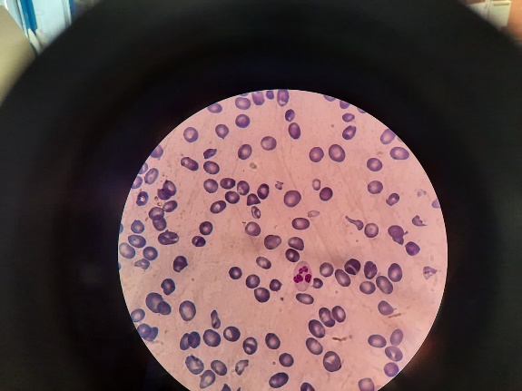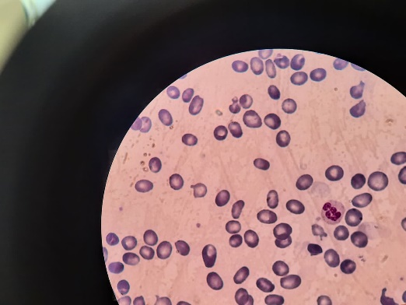

Image1: PBS

According to the PBS, megaloblastic anemia was raised as the first diagnosis and a request for vitamin B12 and folate serum levels was sent, and the treatment was started with a high dose of B12 (1000 micrograms daily) and folate 5 mg daily. And other requested tests were sent to rule out other differential diagnoses.

Considering the changes in the patient's tests in the hospital, drop of platelets to 14000 and WBC to less than 1000, as well as the presence of this amount of schistocytes in the peripheral blood smear, which could not be justified by the usual course of megaloblastic anemia, The patient underwent BMA/B on the fifth day of hospitalization to rule out other concurrent diagnoses and biopsy was seen and a hypercellular bone marrow was reported, suggesting the possibility of MDS or AML-M6. Flow cytometry and cytogenetics were sent and the answer was followed up. The requested CD markers were negative and 4% dysplasia was reported, and the diagnosis of MDS-MLD was raised, the pathologist recommended to rule out nutritional deficiencies as a differential diagnosis.

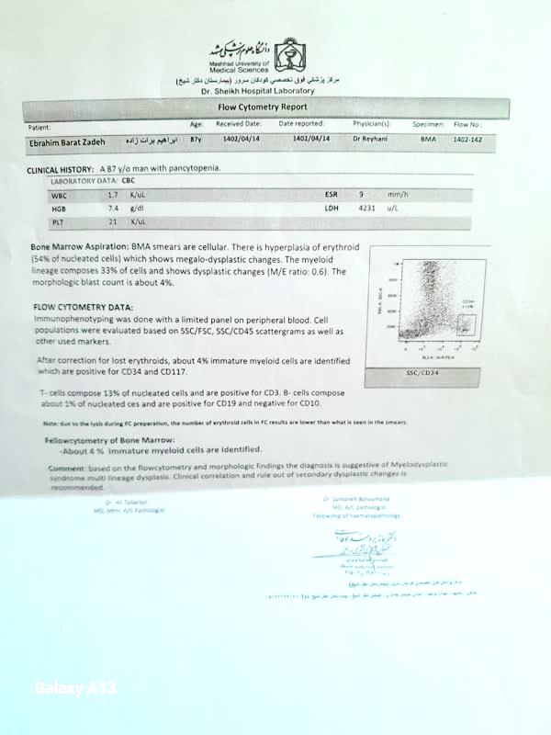

Image 2: bone marrow aspiration and flow cytometry data

According to the patient's bedside manner and the improvement of the tests in the following days, (the seventh day from the start of treatment with high dose B12 and folate), the patient was discharged and the patient's CBC was followed up one week and one month after discharge with the continuation of vitamin B12 and folate treatment, It was normal.

|  |  |  |  |  |  |  |
| --- | --- | --- | --- | --- | --- | --- |
| **Normal** | **2 week later** | **1 week later** | **4 days later** | **2 days later** | **admission** |  |
| 4000-11000 | 4300 | 2100 | 1000 | 1200 | 1500 | **WBC** |
| Male:4.5-6 female:4-5.1 | 2.9 | 2.38 | 1.92 | 2.08 | 1.15 | **RBC** |
| Male: male:14-17.5 | 9.8 | 7.3 | 6.5 | 7.1 | 4.7 | **Hb** |
| Male: 40-50 | 30.4 | 24.8 | 20.3 | 22.3 | 14.6 | **HCT** |
| 80-96 | 103.6 | 104 | 105.7 | 107 | 127.0 | **MCV** |
| 27-33 | 33.5 | 31 | 33.9 | 34 | 40.9 | **MCH** |
| 32-36 | 32.3 | 29 | 32.0 | 32 | 32.2 | **MCHC** |
|  | 60 | 46 | 41.8 | 50.4 | 45.8 | **Neutrophils** |
|  | 34 | 42 | 45.2 | 39.3 | 44.1 | **Lymphocyts** |
|  | 6 | 12 | 13 | 10.3 | 10.1 | **Mix** |
| 150000-450000 | 175000 | 62000 | 14000 | 19000 | 21000 | **platelet** |
|  | 22.7 | 22 | 25.7 | 26.7 | 24.2 | **RDW** |
|  | 1460 | 880 | 500 | 500 | 700 | **Lymphocyts** |
| Male: < 120 Year (s) 8-24 |  | 20 | 21 | 23 | 28 | **BUN** |
| 2 - 120 Year (s) 0.7-1.4 |  | 0.93 | 0.97 | 0.91 | 0.83 | **Creatinine** |
| 135-145 |  | 141 | 137 | 139 | 137.6 | **Na.** |
| 3.5-5 |  | 4.19 | 4.1 | 4.6 | 4 | **K** |
|  |  | 1 | 1.74 | 1.9 | 2.3 | **Bilirubin Total** |
| 0.1-0.3 |  | 0.34 | 0.53 | 0.54 | 0.83 | **Bilirubin Direct** |
| <37 | 26 |  |  |  | 63 | **AST** |
| <41 | 30 |  |  |  | 53 | **ALT** |
| Male: 90-360 | 116 |  |  |  | 115 | **ALP** |
|  | 1400 | 1700 | 2320 | 2540 | 8086 | **LDH1** |
| 0-20 | 9 |  |  |  | 63 | **ESR** |
| Negative<6 |  |  |  |  | 3 | **CRP** |
|  |  |  |  |  | 48 | **Ferritin** |
|  |  |  |  |  | 145 | **iron** |
|  |  |  |  |  | 305 | **TIBC** |
|  |  |  |  |  | 8.6 | **Folic acid** |
|  |  |  |  |  | 56 | **VIT B12** |
|  |  |  |  | Negative |  | **Indirect Combs** |
|  |  |  |  | 0.5 |  | **Reticulocytes** |
|  |  |  |  | Negative |  | **Direct Combs** |
|  |  |  |  | Negative |  | **HCV Ab** |
|  |  |  |  | Negative |  | **HIV Ab** |
|  |  |  |  | Negative |  | **HBS Ag** |
|  |  |  |  | Negative |  | **ANA** |
|  |  |  | Negative |  |  | **COLD agglutinin titre** |

**Discussion**

Vitamin B12 (cobalamin CBL) is a water-soluble vitamin required to form hematopoietic cells (red blood cells, white blood cells, and platelets). It is involved in the process of synthesizing DNA and myelin sheath (6). Vitamin B12, also known as cobalamin, is found in animal products, including fish, meat, poultry, eggs, and dairy. The most common causes of vitamin B12 deficiency include difficulty absorbing vitamin B12 from food, lack of intrinsic factor due to pernicious anemia, prior gastrointestinal surgery, prolonged use of certain medications such as metformin and proton pump inhibitors, and dietary deficiency (7).

Malnutrition, often called insufficient nutrition, is a common condition with advancing age. Malnutrition is associated with unfavorable outcomes in older subjects (8). The prevalence of anemia is also high in the elderly(6). anemia in older individuals can be secondary to potentially inappropriate prescribing (9), low protein intake and albumin levels(10), and selective nutritional deficiency (11).

B12 deficiency is more common among individuals over 60 years of age due to the increased prevalence of pernicious anemia, atrophic gastritis, and infection with Helicobacter pylori and malnutrition (7).

Adverse outcomes of B12 deficiency can manifest as hematologic or neurologic consequences. A hallmark sign of B12 deficiency is megaloblastic anemia, classically found with Oval macrocytes, usually with considerable anisocytosis and poikilocytosis, are the main feature. Some of the neutrophils are hypersegmented (more than five nuclear lobes). There may be leukopenia due to a reduction in granulocytes and lymphocytes, but this is usually >1.5 × 109/L; the platelet count may be moderately reduced, rarely to <40 × 109/L. The severity of all these changes parallels the degree of anemia (12–17) a combination of these, or (rarely) pancytopenia and hemolysis. In our patient, along with the presence of schistocytes in the peripheral blood smear -MAHA-,very high LDH serum level, platelets decreased to 14,000 and leukocytes decreased to 1,000. Only two-thirds of B12 deficient patients may manifest hematological abnormalities(18). in fact, pancytopenia, in which all blood cell lines are decreased, is seen in only 5% of patients with a known B12 deficiency (18). Hemolysis and Increased levels of lactate dehydrogenase (LDH) and bilirubin in B12 deficiency most often occurs within the bone marrow, often referred to as intramedullary hemolysis or ineffective erythropoiesis (6,18). Extra medullary hemolysis has also been rarely reported secondary to a variety of factors, most often via antibody-mediated destruction, high levels of homocysteine leading to endothelial dysfunction and lysis, or due to mechanical destruction of poorly formed red blood cells as they traverse small capillaries beds (20). These processes explain the elevation of both LDH and bilirubin in patients with megaloblastic anemia, as they reflect the underlying hemolytic activity and ineffective erythropoiesis associated with the disease (21,22). In megaloblastic anemia, the reticulocyte count can be variable. Typically, when the body experiences hemolysis or significant loss of red blood cells, it compensates by increasing reticulocyte production from the bone marrow. Ineffective Erythropoiesis and Reticulocyte Crisis after treatment are other couses of increase Reticulocyte in megaloblastic anemia (22,23).

In summary, increased LDH and bilirubin levels in megaloblastic anemia arise from hemolysis associated with ineffective erythropoiesis due to vitamin b12 deficiencies. The reticulocyte count serves as an indicator of bone marrow response but may not always reflect effective erythropoiesis due to the nature of megaloblasts produced during this condition.

The initial presentation with pancytopenia, splenomegaly and leukoerythroblastosis was very concerning for an underlying malignancy. severe megaloblastic anemia may be mistaken for acute leukemia(20). In this patient, due to the progressive course of pancytopenia despite the initiation of proper treatment with the possibility of leukemia, the patient underwent a bone marrow biopsy.

Neurological changes associated with B12 deficiency include sensory deficits, paresthesia, weakness, ataxia, and gait disturbance, while severe cases can cause spasticity and paraplegia (7).

deficiency is based on the concordance of anamnestic, clinical, cytological elements and the assay of associated biomarkers. The serum dosage of vitamins B12 and B9 should be included in the initial etiological assessment of pancytopenia, due to non-specificity of clinical signs. The manifestations of cobalamin and folate deficiency are relatively similar, reflecting their intricate co-enzymatic functions. In industrialized countries, provided the diet is balanced and in the absence of underlying disease, vitamin requirements are covered and deficiencies of nutritional origin are rare The importance of early diagnosis and prompt vitamin supplementation, due to potential complications, must be underlined (24).

Due to the significant complications and severe morbidity caused by the late treatment of the deficiency of these vitamins, it is necessary to start the treatment quickly and with a sufficient dose.

**Conclusions**

Oval macrocytes, usually with considerable anisocytosis and poikilocytosis, are the main feature. Some of the neutrophils are hypersegmented (more than five nuclear lobes). There may be leukopenia due to a reduction in granulocytes and lymphocytes, but this is usually >1.5 × 109/L; the platelet count may be moderately reduced, rarely to <40 × 109/L. The severity of all these changes parallels the degree of anemia.

**Acknowledgments**

The authors extend their gratitude to the Clinical Research Development Unit of Bohlool Hospital at Gonabad University of Medical Sciences for their invaluable support in the preparation of the present manuscript.

**Authors’ contributions**

Contributed to the design of the manuscript: AB; carried out the search based on the keywords: MT and AB; Contributed to the drafting of the manuscript and case report: MT and AB. All authors approved the last version of the manuscript.

**Funding**

The authors affirm that they have no conflicts of interest to disclose.

**Ethical Considerations**

This study was approved by the Ethics Committee of the Gonabad University of Medical Sciences (Code: IR.GMU.REC.1403.048).

**References**

1. Gnanaraj J, Parnes A, Francis CW, Go RS, Takemoto CM, Hashmi SK. Approach to pancytopenia: Diagnostic algorithm for clinical hematologists. Blood Rev. 2018;32(5):361–7.

2. Khan MN, Ayyub M, Nawaz KH, Naqi N, Hussain T, Shujaat H. Pancytopenia: clinicopathological study of 30 cases at Military Hospital, Rawalpindi. Pak J pathol. 2001;12(2):37–41.

3. Tariq M, Basri R, Khan NU, Amin S. Aetiology of pancytopenia. Prof Med J. 2010;17(02):252–6.

4. Khattak MB, Ismail M, Marwat ZI, Khan F. Frequency and characterisation of pancytopenia in megaloblastic anaemia. J Ayub Med Coll Abbottabad. 2012;24(3–4):53–5.

5. Sasi S, Yassin MA. A rare case of acquired hemolytic anemia and pancytopenia secondary to pernicious anemia. Case Rep Oncol. 2020;13(2):783–8.

6. Costanzo G, Sambugaro G, Mandis G, Vassallo S, Scuteri A. Pancytopenia secondary to Vitamin B12 deficiency in older subjects. J Clin Med. 2023;12(5):2059.

7. Pelling MM, Kimura ST, Han EJ, Shin YM, Pelling M, Kimura S. Severe vitamin B12 deficiency presenting as pancytopenia, hemolytic anemia, and paresthesia: could your B12 be any lower? Cureus. 2022;14(9).

8. Li H, Cen K, Sun W, Feng B. Prognostic value of geriatric nutritional risk index in elderly patients with heart failure: a meta-analysis. Aging Clin Exp Res. 2021;33:1477–86.

9. Manzocco M, Delitala A, Serdino S, Manetti R, Scuteri A. The appropriateness of antiplatelet and anticoagulant drug prescriptions in hospitalized patients in an internal medicine ward. Aging Clin Exp Res. 2021;33:2849–55.

10. Röhrig G, Becker I, Polidori MC, Schulz RJ, Noreik M. Association of anemia and hypoalbuminemia in German geriatric inpatients. Z Gerontol Geriatr. 2015;48(7).

11. Caprari P, Scuteri A, Salvati A, Bauco C, Cantafora A, Masella R, et al. Aging and red blood cell membrane: a study of centenarians. Exp Gerontol. 1999;34(1):47–57.

12. Bunn HF. Vitamin B12 and pernicious anemia—the dawn of molecular medicine. N Engl J Med. 2014;370(8):773–6.

13. Carmel R. Subclinical cobalamin deficiency. Curr Opin Gastroenterol. 2012;28(2):151–8.

14. Devalia V, Hamilton MS, Molloy AM, Haematology BC for S in. Guidelines for the diagnosis and treatment of cobalamin and folate disorders. Br J Haematol. 2014;166(4):496–513.

15. Hesdorffer CS, Longo DL. Drug-induced megaloblastic anemia. N Engl J Med. 2015;373(17):1649–58.

16. Morris JK, Rankin J, Draper ES, Kurinczuk JJ, Springett A, Tucker D, et al. Prevention of neural tube defects in the UK: a missed opportunity. Arch Dis Child. 2016;101(7):604–7.

17. Huo Y, Li J, Qin X, Huang Y, Wang X, Gottesman RF, et al. Efficacy of folic acid therapy in primary prevention of stroke among adults with hypertension in China: the CSPPT randomized clinical trial. Jama. 2015;313(13):1325–35.

18. Andrès E, Affenberger S, Zimmer J, Vinzio S, Grosu D, Pistol G, et al. Current hematological findings in cobalamin deficiency. A study of 201 consecutive patients with documented cobalamin deficiency. Clin Lab Haematol. 2006;28(1):50–6.

19. Qiong, Wu., Junru, Liu., Xiaoxuan, Xu., Beihui, Huang., Dong, Zheng., Juan, Li. 1. Mechanism of megaloblastic anemia combined with hemolysis.. Bioengineered bugs, (2021). doi: 10.1080/21655979.2021.1952366.

20. Ballas SK. Abnormal erythrocyte membrane protein pattern in severe megaloblastic anemia. J Clin Invest. 1978;61(4):1097–101.

21. Dhande D, Dhok A, Anjankar A, Nagpure S. A Case Report and Literature Review on Dietary Practices and Megaloblastic Anemia in a Young Female: Unraveling the Impact of Nutrition on Hematological Health. Cureus. 2024 Jun;16(6):e61550.

22. Wafaa H, Magadmi R, Hakami N, Al Sadoun H, Almaghrabi S, Mohammed N, et al. Is Vitamin B12 Level a Reliable Predictor of Psychosis Severity in Male Patients with Megaloblastic Anemia at a Single Tertiary Hospital? Int J Gen Med. 2022;15:7657–68.

23. Liu A, Jacobs-McFarlane C, Sebastiani P, Glassberg J, McCuskee S, Curtis S. Plasma free hemoglobin is associated with LDH, AST, total bilirubin, reticulocyte count, and the hemolysis score in patients with sickle cell anemia. Research square. United States; 2024.

24. Depuis Z, Gatineau-Sailliant S, Ketelslegers O, Minon JM, Seghaye MC, Vasbien M, et al. Pancytopenia Due to Vitamin B12 and Folic Acid Deficiency—A Case Report. Pediatr. Rep. 2022, 14, 106–114. s Note: MDPI stays neutral with regard to jurisdictional claims in published …; 2022.